**Master Functional Documnet**

|  |  |
| --- | --- |
| **Application** | NGERP - Centra |
| **Service Bundle** | Master Management |
| **Service Request** | Document Sequence |

**Description:**

In Compiere (NGERP - Centra), the Document Sequence feature defines how document numbers are generated and sequenced. You can customize the document numbering by adding prefixes, suffixes, and adjusting the current number.

**Workflow Process:**

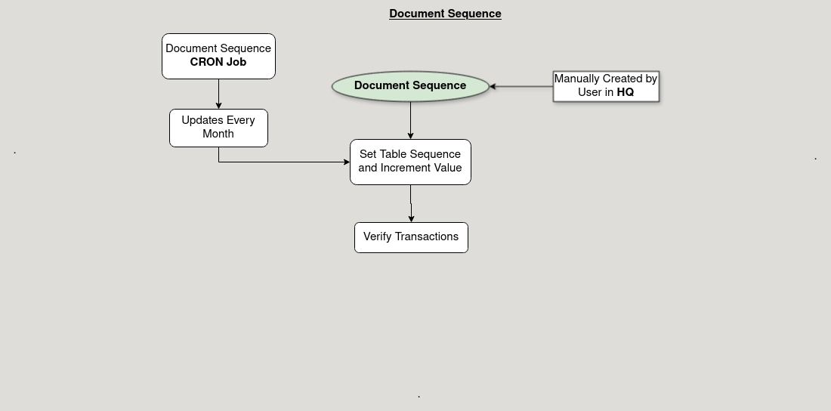

**Business Rules:**

* Document sequence are visible in both HQ and ROW.
* Creation of document sequence is possible in both HQ and ROW.
* Sequence defines the numbering system for documents.
* Auto numbering automatically assigns the next number in the sequence.
* Increment defines how much the document number will increase with each new document.